**Date: 2016.10.24**

Request:

RF loading Module:

-          WMS will block for the next scanning when Error Message prompt out, able to proceed the next scanning when the “OK” button is press.

**Current:**

**Over shipped issue:**

On the current loading process when we scan the wrong ship to code package, the RF will prompt out a message. It will just continue when we scan the next package.

We would like to change that when the message prompt out WMS will block it and we need to press the “OK” button then we can proceed for the next scanning. Please help on this CA ASAP. Thanks

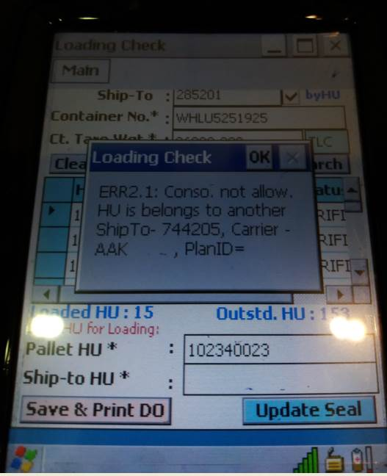

RF Login Test , please use

For TLC RF

Login    = Vwn.test2

Password = 222222

For SLC

            Login =  vwn.test

            Password = 123456

RF Loading Changes:

**Deployed 2016.12.01**

Message prompt as below,

User require to click [Close] button to proceed.

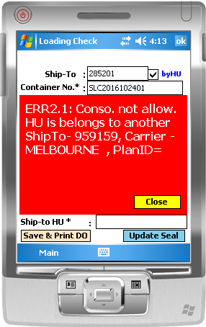

After click [Close], screen loading resume:

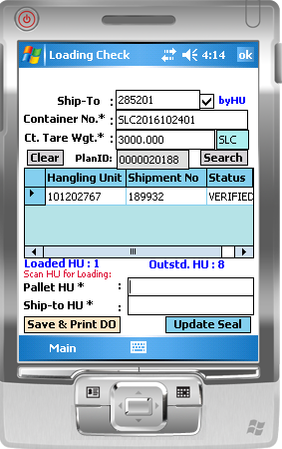

New Outbound Scanning Error report:

Report captured the error scanning cross ship-to

